**Southern Highlands Conference on Heterocyclic Chemistry**

**Sebel Harbourside Kiama 27th – 29th August 2023**

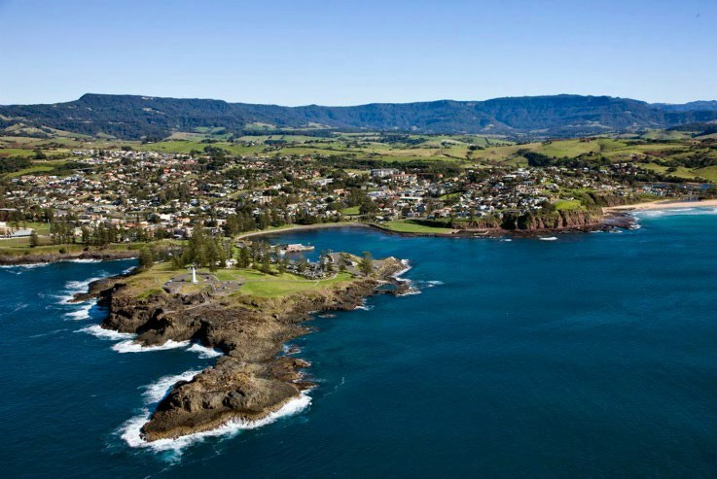 ABN 81 747 687 337



**Registration Form**

Title: Prof  Assoc. Prof  Dr  other (please specify)  (blank)

|  |  |
| --- | --- |
| Full name |  |
| Phone number |  |
| Business address |  |
| Email address |  |

We would like to create an email list of conference attendees to be distributed amongst conference attendees (only), to allow to extended discussions, including post-conference – please tick this box as permission to add your name to this list.

***Registration fees including accommodation and meals (payable by 28 July 2023)***

**AUD $595 pp twin share**

**AUD $780 pp single room**

**AUD $15 Wine tasting (optional – see later)**

|  |  |
| --- | --- |
| Total payment (in addition to any bank fees) |  |

Payment format: Direct deposit

Commonwealth Bank, UNSW Branch

Account name: Southern Highlands Conference

BSB 062 303

Account 1057 4142

|  |  |
| --- | --- |
| Dietary requirements |  |
| Preferred room partner * |  |

* Note: If you do not indicate a preferred room partner, we will allocate room buddies.

**Postgraduate Student awards**

To encourage student participation and to reward excellence in chemistry, two awards, equivalent to half of the conference registration costs, have been created and will be made to postgraduate students from any Australian university. Awardees will be invited to present a lecture on their research work at the conference. Nominations for the awards must be made in writing with a CV, letter of recommendation (from the supervisor(s)) and an A4 abstract to Professor Paul Keller at the registration address by July 16th 2023.

Postgraduate Poster prizes will also be awarded.

***Conference presentations***

I wish to present:  (Lecture - for students, awarded on a competitive basis)

(Poster - Academics and students are encouraged to present)

|  |  |
| --- | --- |
| Title and author  (Indicate presenter) |  |

***Travel arrangements***

I will travel to Kiama by:  car  train  flight to Shellharbour  other

Note: Link airways flies direct from Sydney, Brisbane, Melbourne (Essendon), Canberra, Hobart and Newcastle) to Wollongong (Shellharbour) which is 15 minutes’ drive to the conference venue. Collection from the airport can be arranged. For more information visit <https://www.linkairways.com/>

Please return registration form by July 28th 2023 to:

Paul Keller

[keller@uow.edu.au](mailto:keller@uow.edu.au)

(02) 4221 4692

0407 904 373

Proceedings will begin at 3.30 pm on Sunday with afternoon tea and the first two plenary lectures, and conclude at about 3.30 pm on Tuesday afternoon.

**Map to Venue:** (travelling by car from the North)

**Wine tasting (Optional)**

Monday afternoon is free time and there is the opportunity to visit one of the numerous local wineries. If you would like to attend, please tick the appropriate box below and add the cost to the ‘Total Payment’. Please note that travel by car by conference members will need to be arranged at the conference (i.e. no official transport will be arranged by the conference organisers).

**Two Figs Winery** (<https://www.twofigs.com.au>). $15.00 per head (maximum 6 people)

**Crooked River Wines** (https://www.crookedriverwines.com/). $15.00 per head (maximum 10 people)